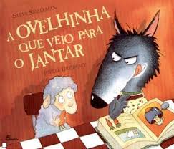
Nome: __________________________________________________
Data: ________

Tarefa 5

- Copia a parte do texto que mais gostaste e ilustra-a.
____________________________________________________________________________________________________________________________________________________________________________________________________________________________________________________________________________________________________________________________________________________________________________________________________________________________________
____________________________________________________________________________________________________________________________________________

